**CREATE AWS RDS DATABASE AND CONNECT TO SQL DEVELOPER**

**CREATING RDS DATABASE INSTANCE IN AWS CONSOLE**

1. Login to AWS Educate ( <https://www.awseducate.com/signin/SiteLogin> ) and go to My Classrooms. Select Database Systems 1.

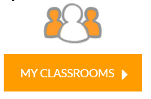



1. Click on AWS Console.

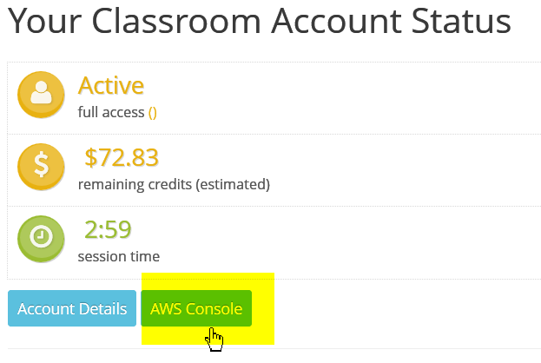

1. On the AWS Console, click on “Services” and in the Group search enter “rds” for Relational Database Services.

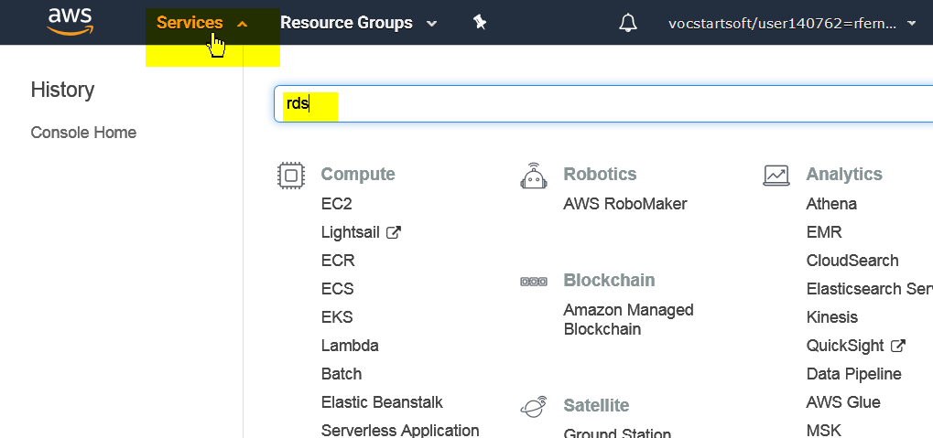

1. Click on ‘Create Database’.

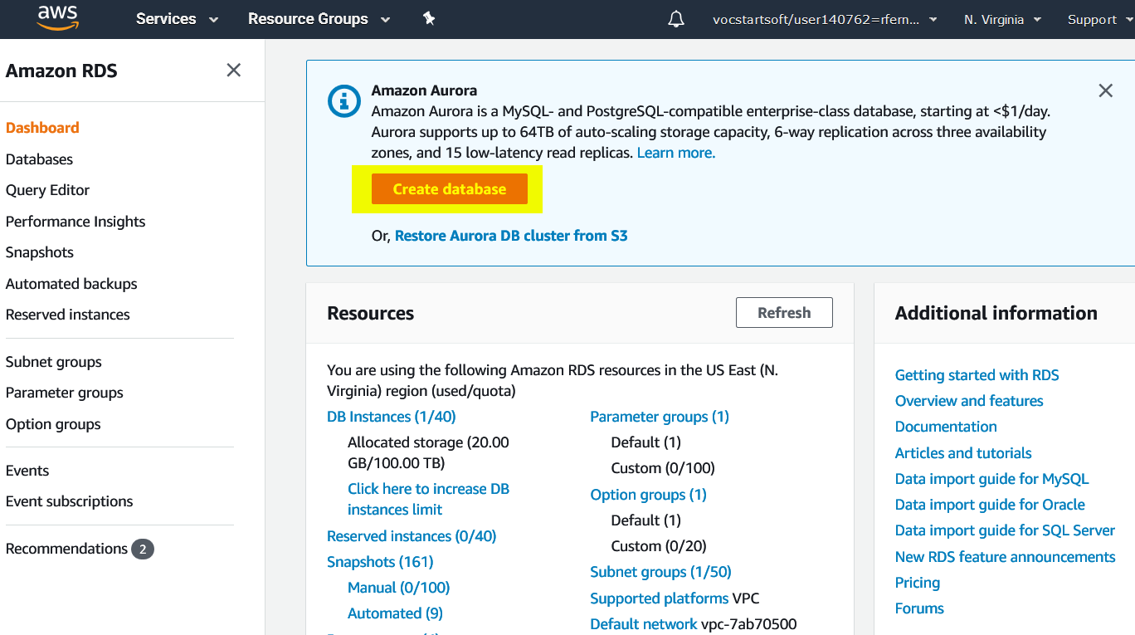

1. Select Oracle and Oracle Enterprise Edition.

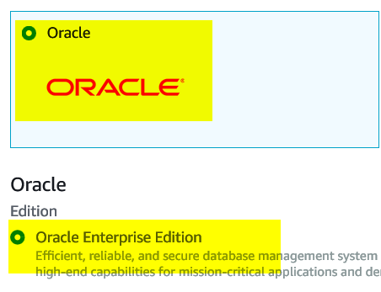

1. Choose Dev/Test and click on Next.

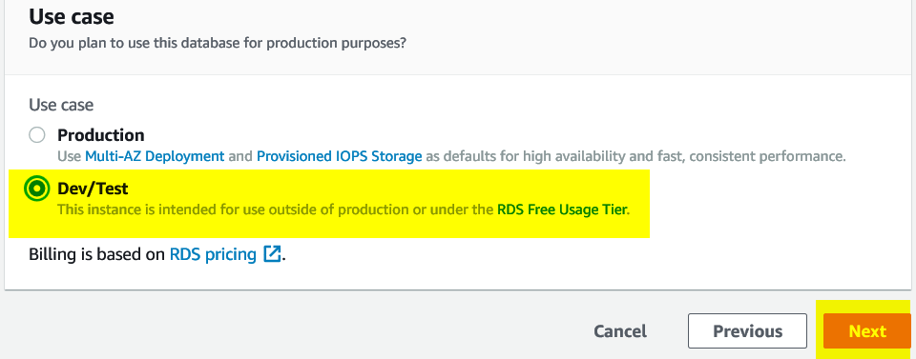

1. For “DB engine version” click on the drop down and select the latest patch level for Oracle 12.2.0.1

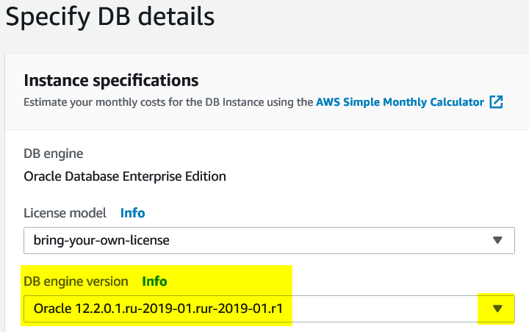

1. Enter a DB instance name. Example: First letter of first name + First 3 letters of last name + any number

Shrestha Choudhury = scho2

1. Enter a username and password of your choice.

Click on Next.

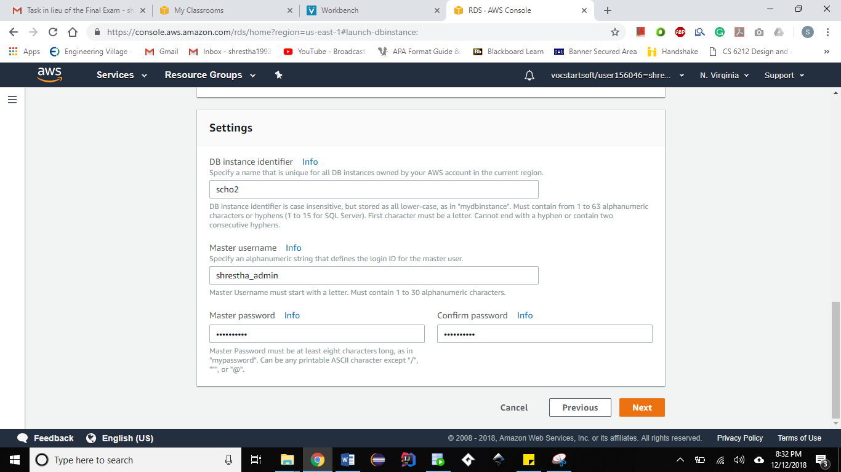

1. Enable Public accessibility and select availability zone.

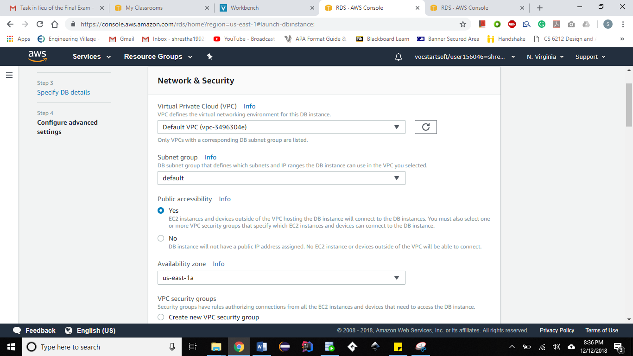

1. Select ‘Create new VPC security group’.

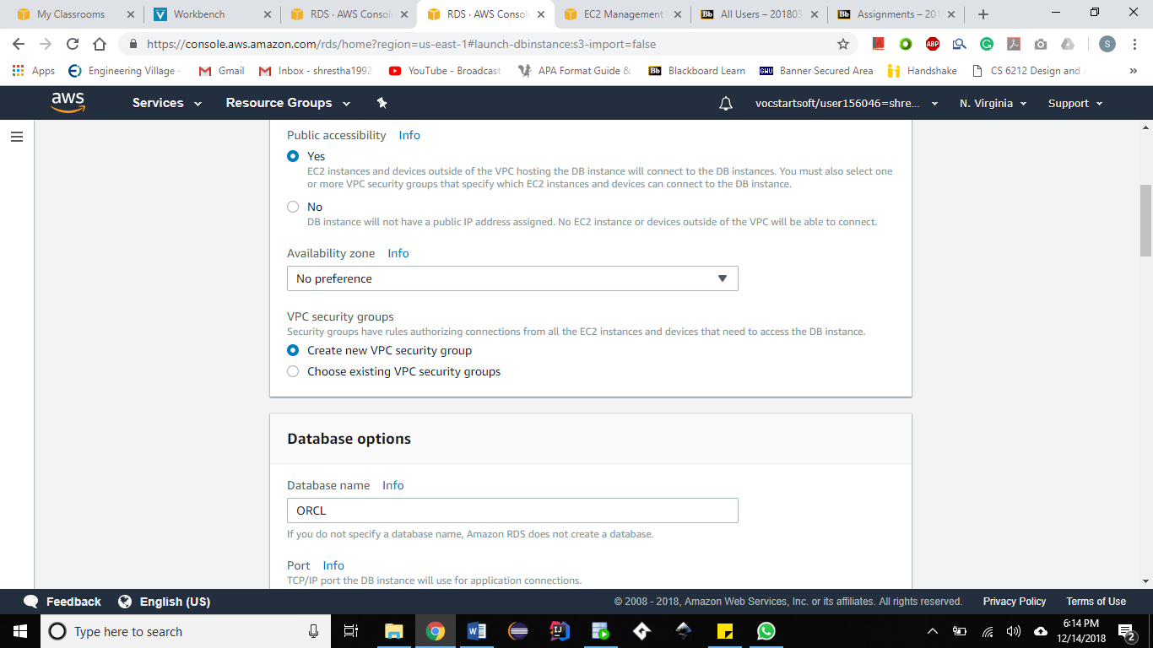

1. Enter the database name same as your DB instance identifier (step 8) to make it easier to remember.

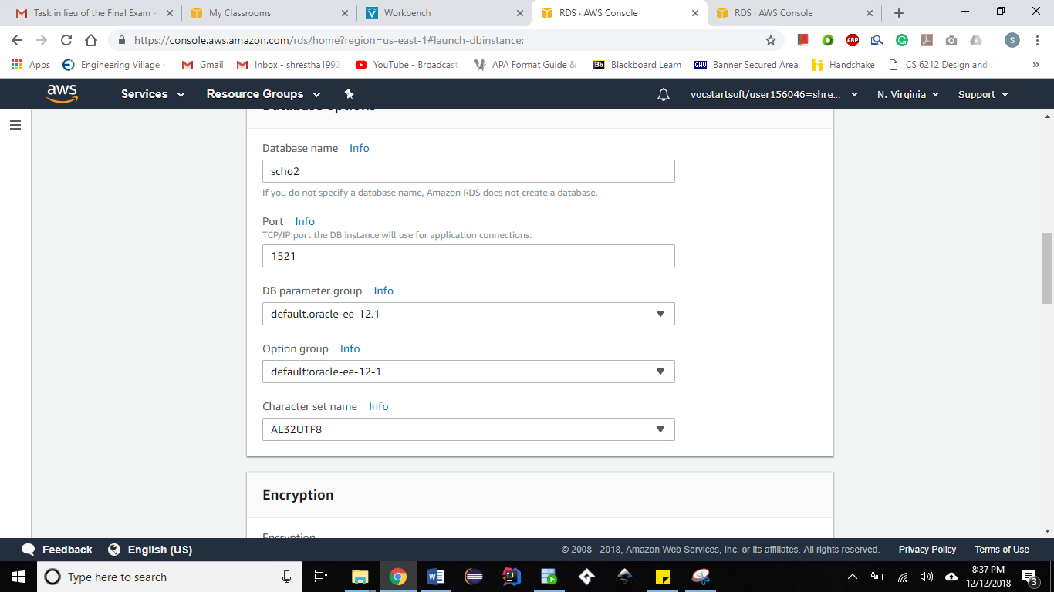

1. Select ‘Enable enhanced monitoring’ and select all checkboxes under ‘Log exports’.

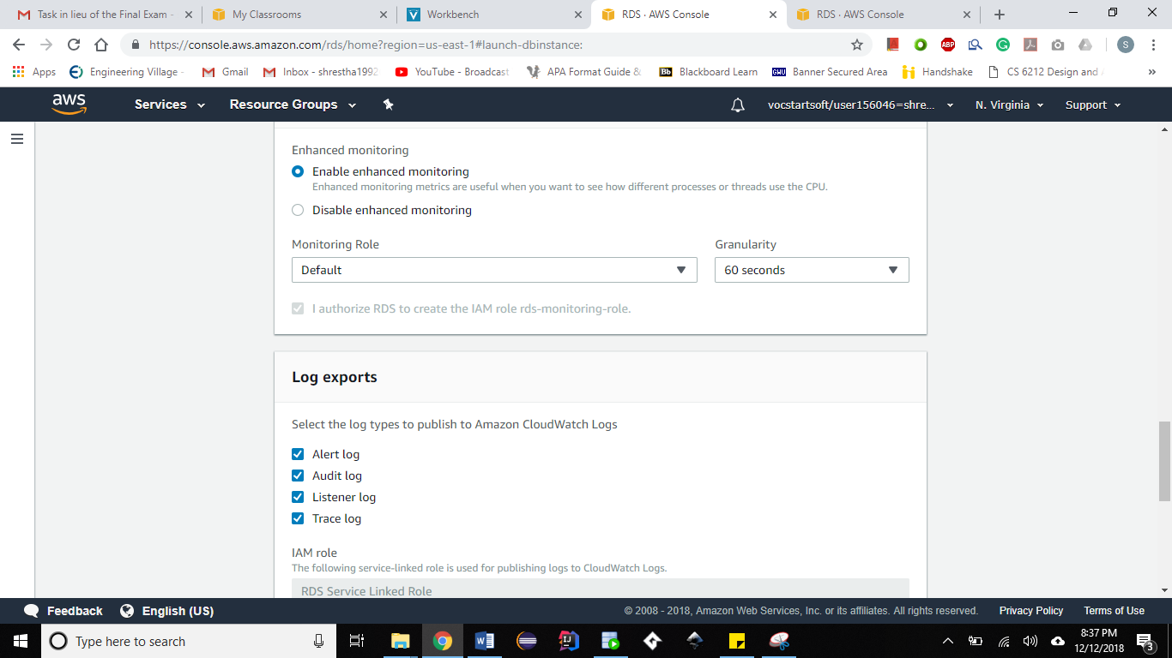

1. Click on ‘Create Database’

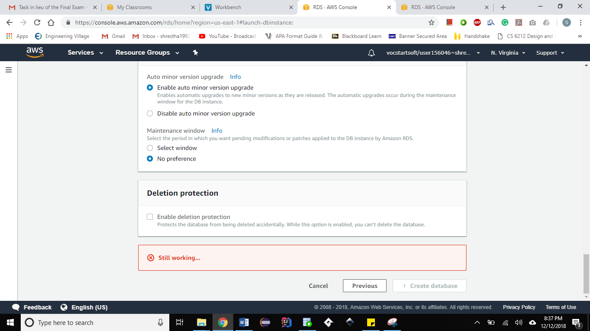

1. Click on ‘View DB instance details’.

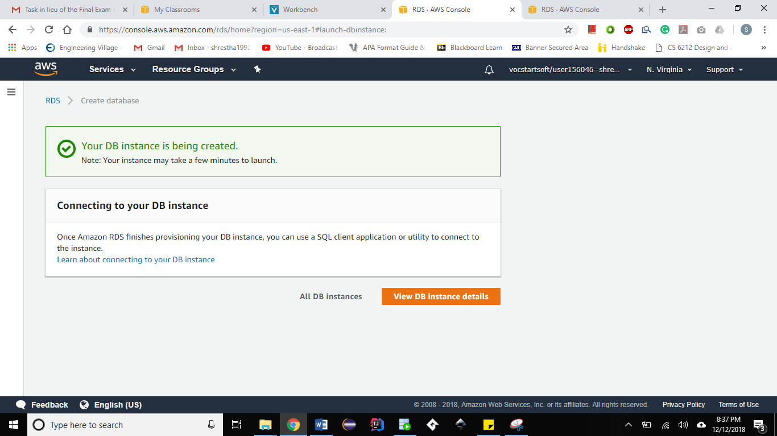

1. Wait until displays ‘Available’. This may take several minutes.

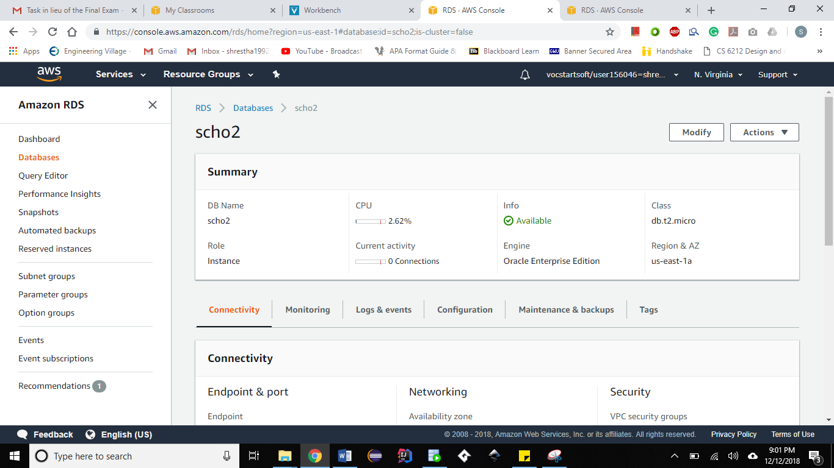

1. Scroll down to the security section and click on the security group name

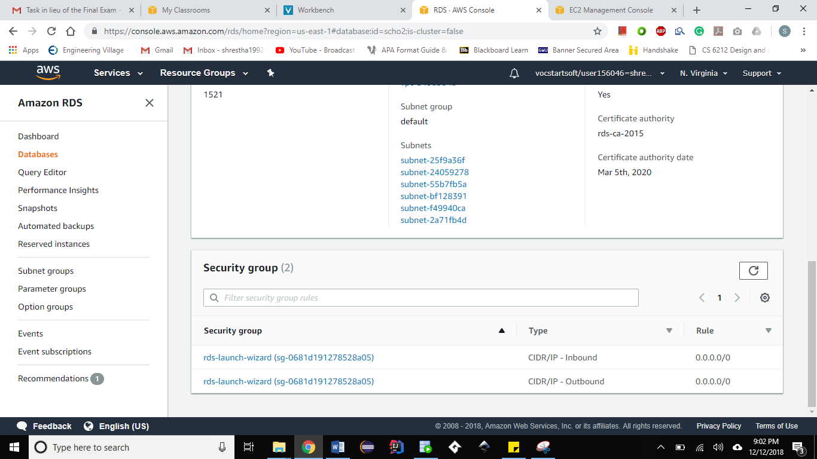

1. Click on Inbound and then click Edit

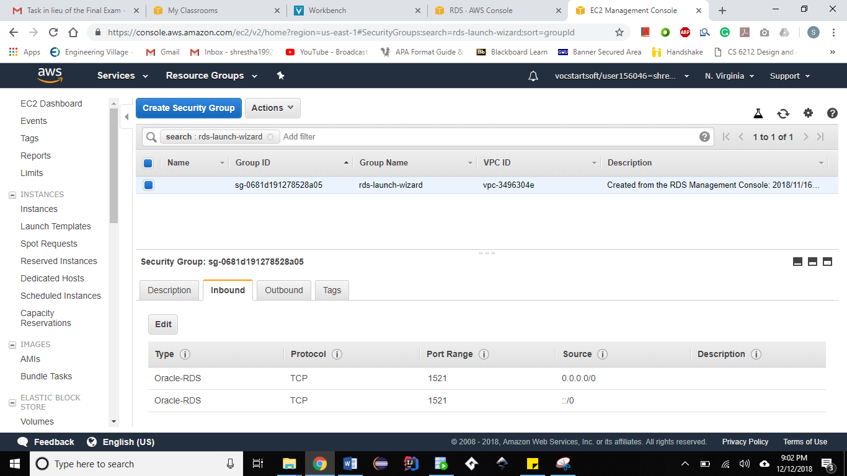

1. Make sure that your parameters match the screenshot below.

Click on Save.

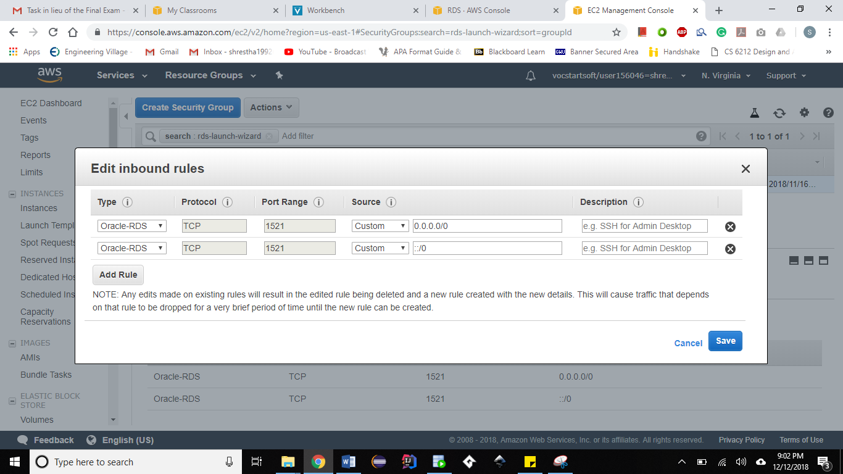

1. Click on Outbound and then click Edit.

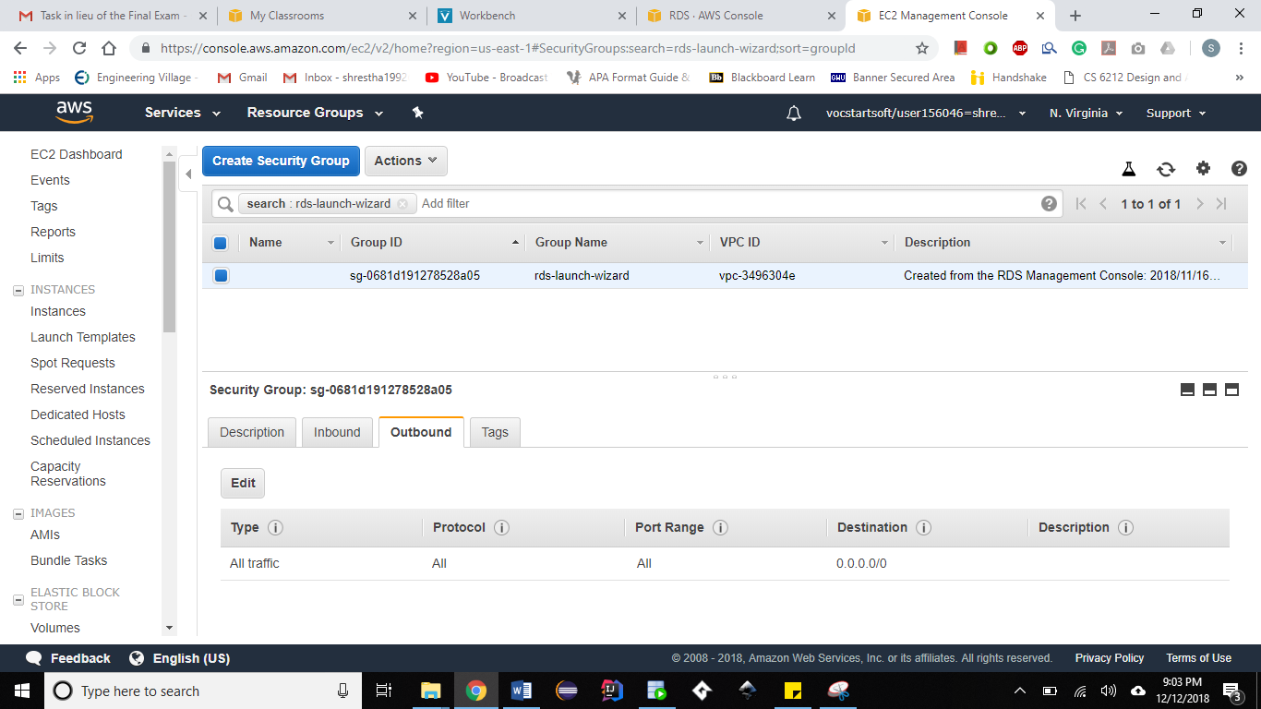

1. Make sure that your parameters match the screenshot below.

Click on Save.

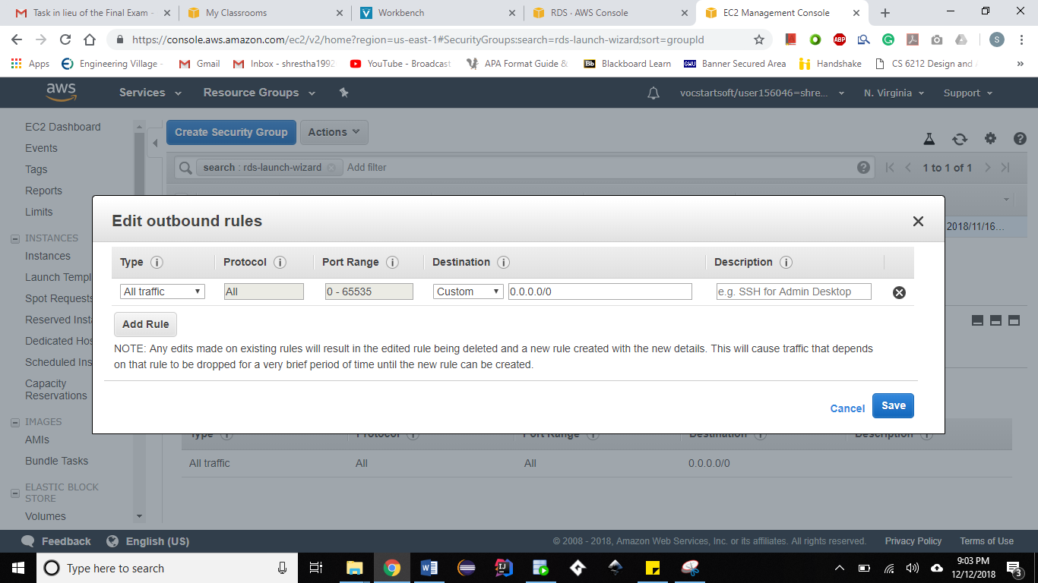

1. Go to RDS -> Databases. Click on the database you created.

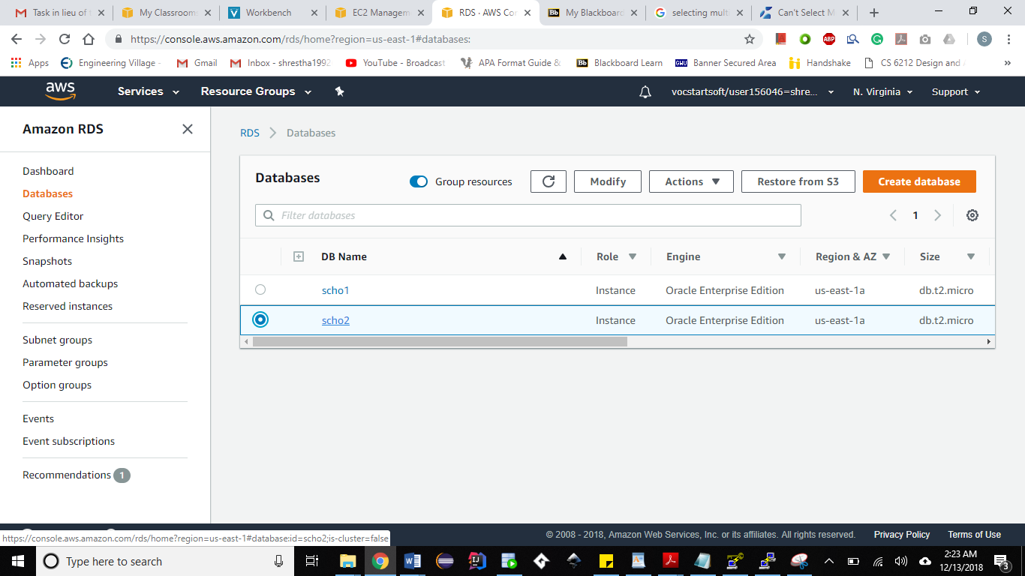

1. Save the Endpoint value under ‘Connectivity’ in notepad. We will use this later.

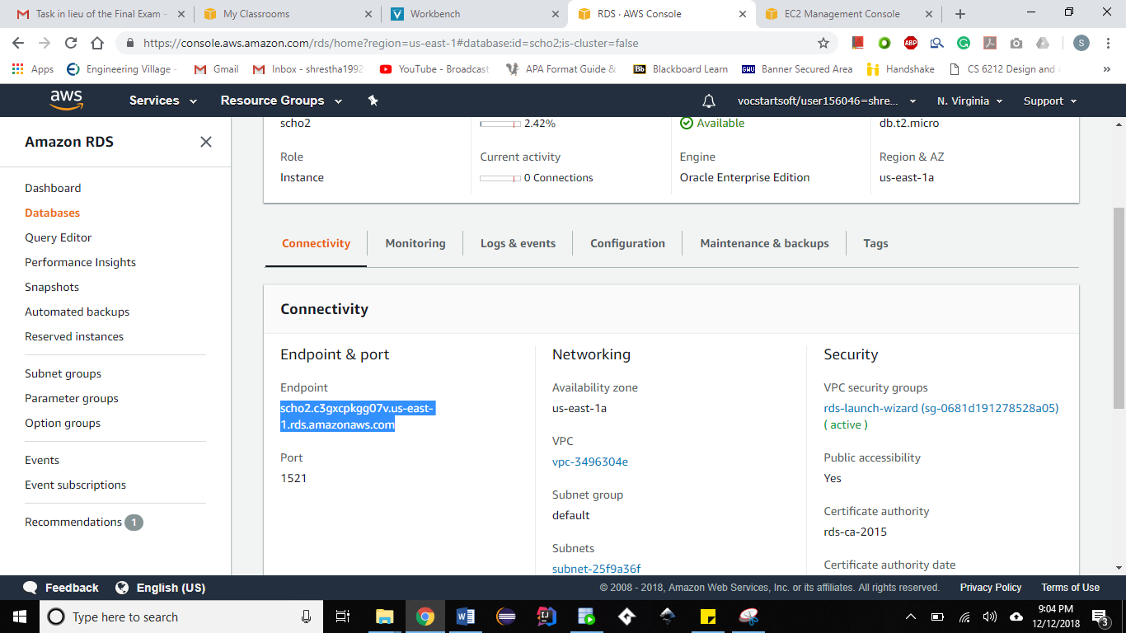

**CONNECTING THE ORACLE SQL DEVELOPER TO THE RDS ORACLE DATABASE INSTANCE**

**The Oracle SQL Developer can be downloaded from:**

<https://www.oracle.com/tools/downloads/sqldev-v192-downloads.html>

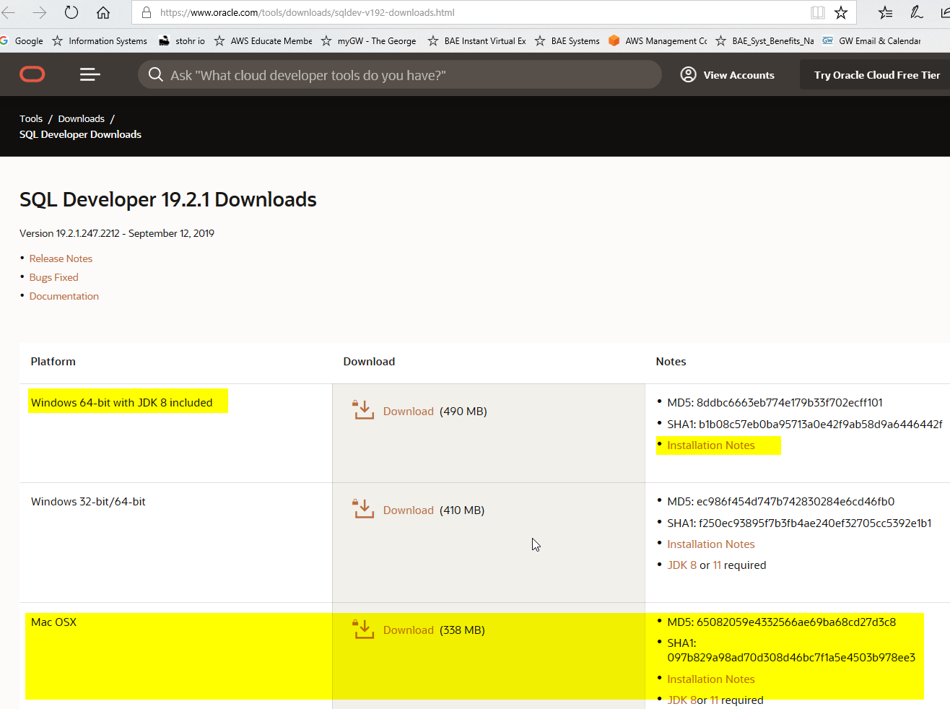

1. Open Oracle SQL Developer and click on New connection
2. Enter the below details and click on Test. You should get ‘Success’.

|  |  |  |
| --- | --- | --- |
| **SQL DEVELOPER CONNECTION** | **AWS RDS INSTANCE** | **STEP IN DOCUMENT** |
| Connection Name | DB instance identifier | From step 9 |
| Username | Master username | From step 9 |
| Password | Master password | From step 9 |
| Hostname | Endpoint | From step 23 |
| Port | 1521 |  |
| SID | Database Name | From step 12 |

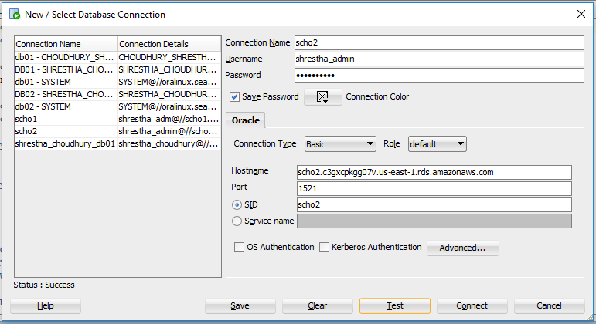

1. Click on Connect.



1. Run queries for the HR Database Schema.

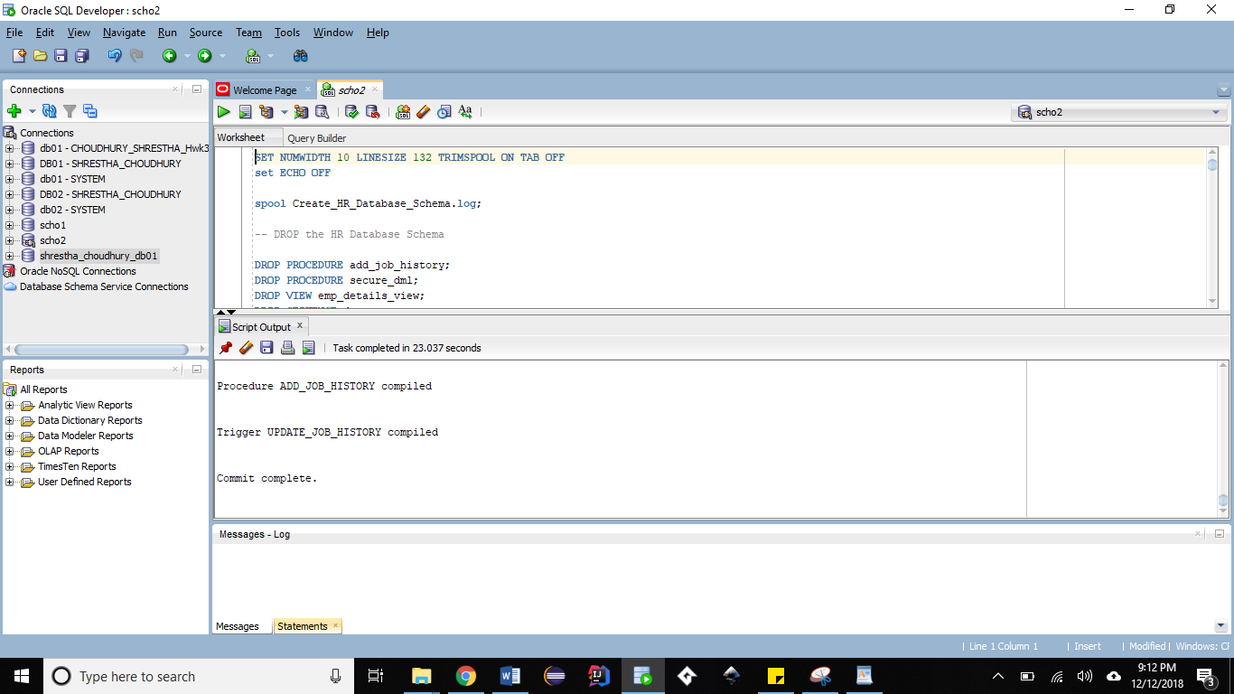

**CONNECT TO ORACLE DATAMODELER AND REVERSE ENGINEER THE DATABASE SCHEMA**

**The Oracle Datamodeler software can be downloaded from:**

[**https://www.oracle.com/technetwork/developer-tools/datamodeler/downloads/dm-downloads-191-5592793.html**](https://www.oracle.com/technetwork/developer-tools/datamodeler/downloads/dm-downloads-191-5592793.html)

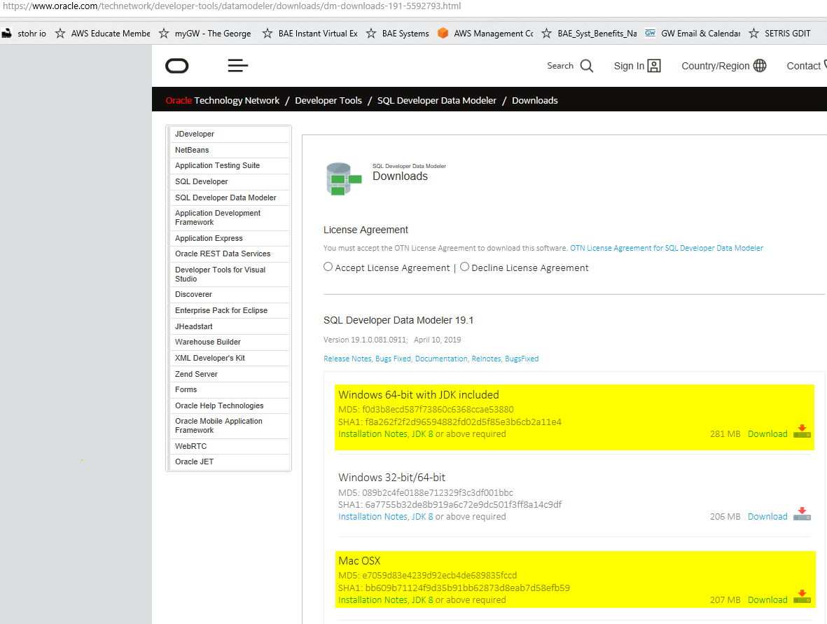

1. Go to Datamodeler -> Import -> Data Dictionary

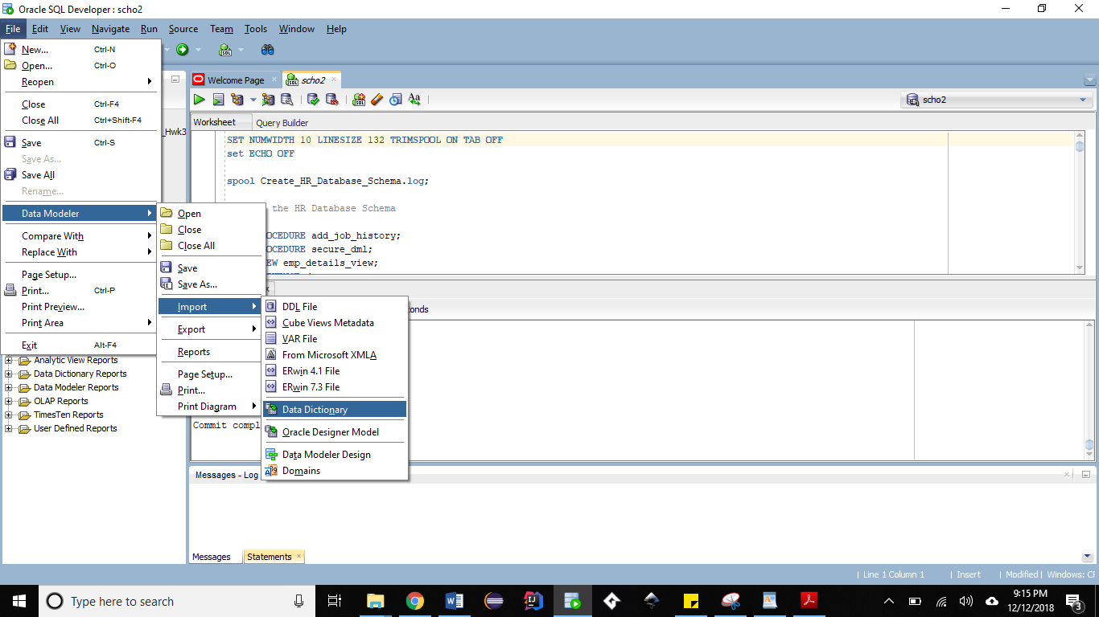

1. Select your connection name and click on Next.

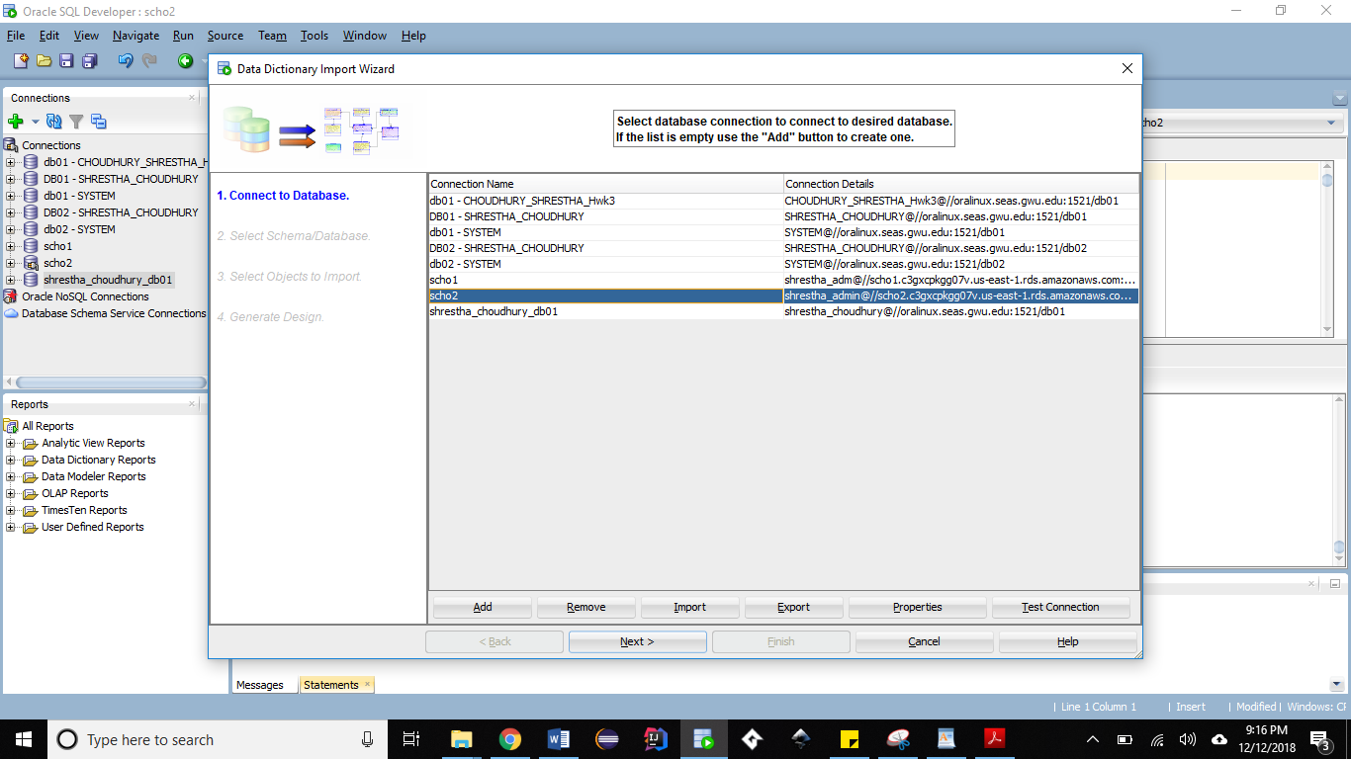

1. Select your user name and click on Next.

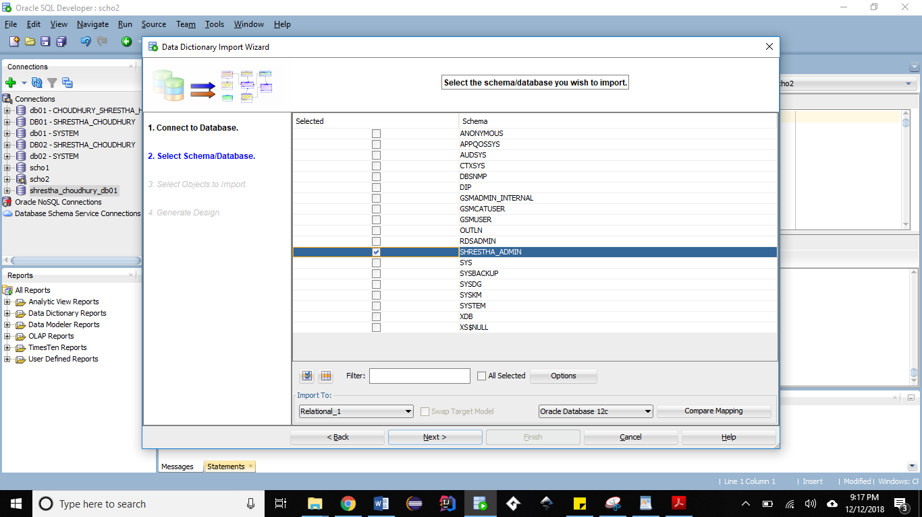

1. Select all the table and click on Next.

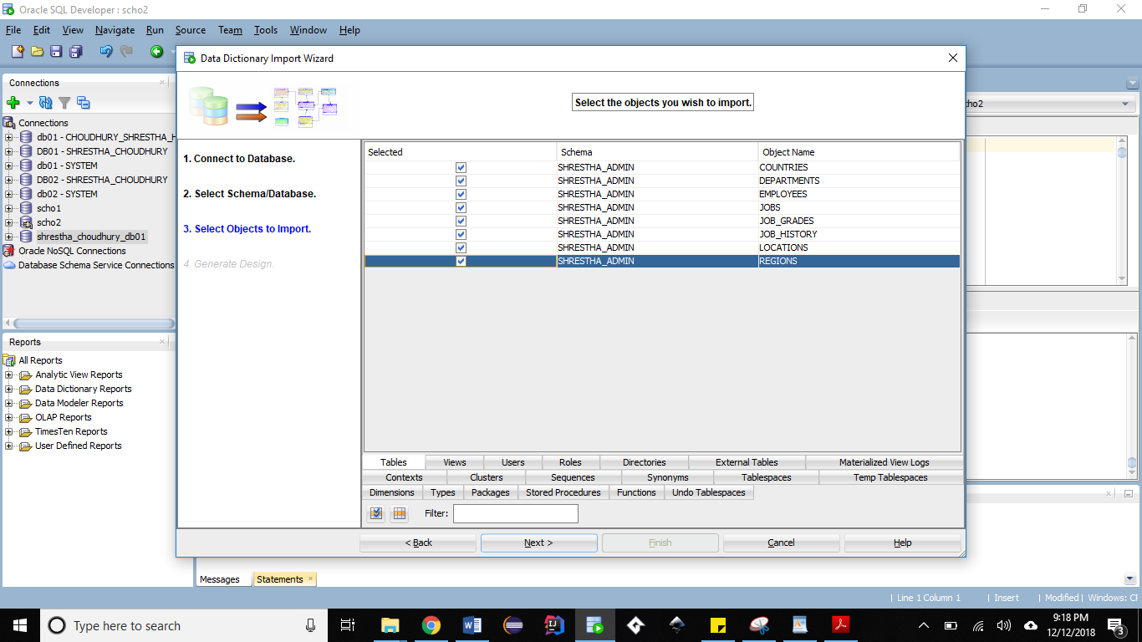

1. Click on Finish.

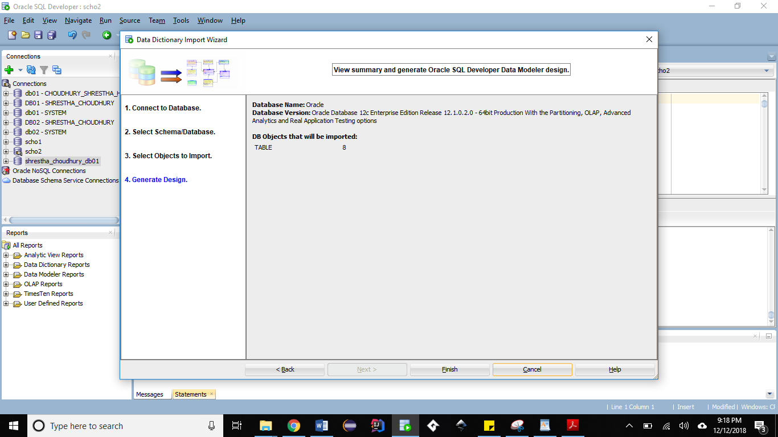

1. Check the log to verify that all tables were imported successfully.

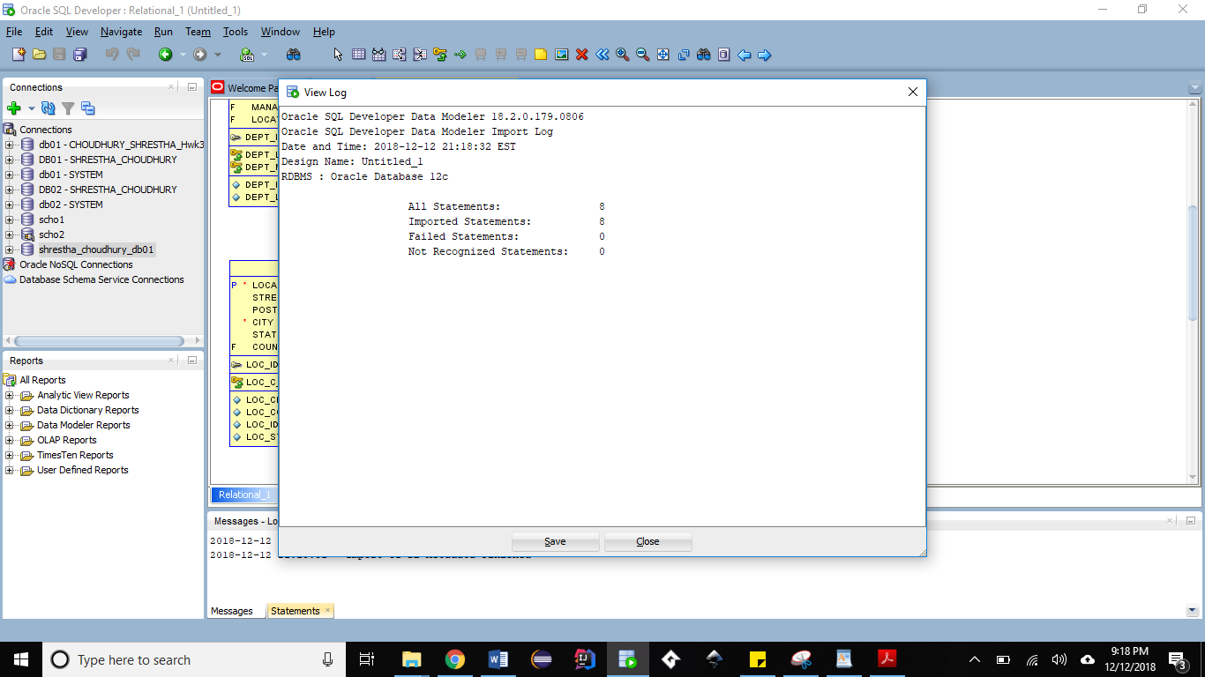

1. This is the Relational diagram of the HR database schema.

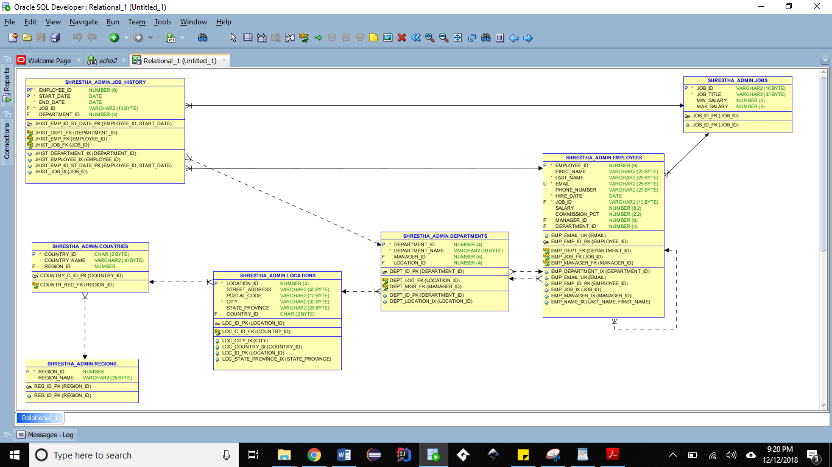

1. Click on ‘Engineer to Logical Model’

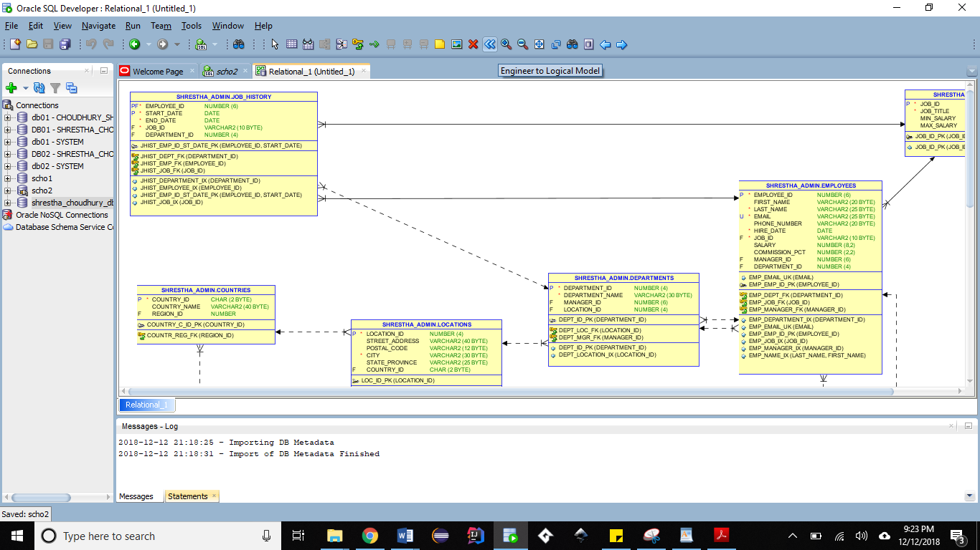

1. Click on Engineer.

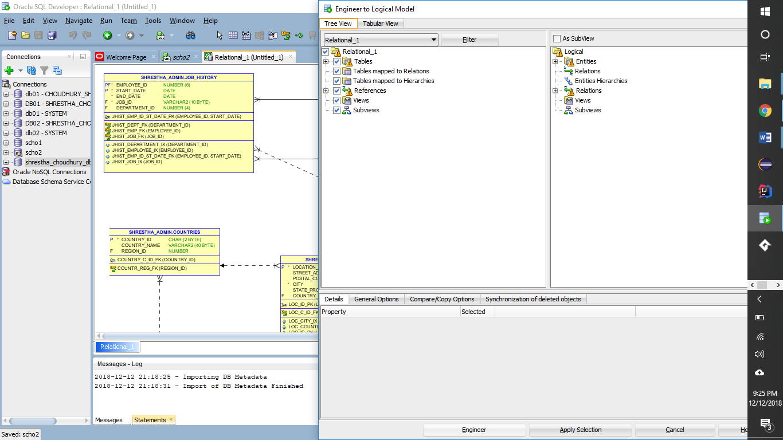

1. This is the Logical diagram of the HR Database schema.

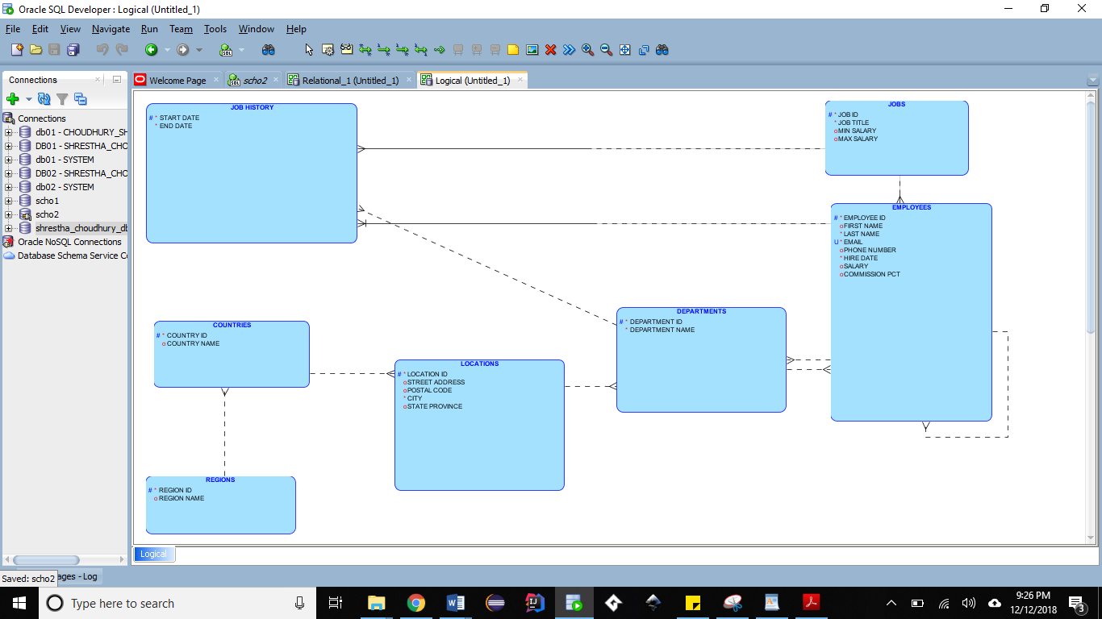

virtual private cloud:

A virtual private cloud (VPC) is an on-demand configurable pool of shared computing resources allocated within a public cloud environment, providing a certain level of isolation between the different organizations (denoted as usershereafter) using the resources. The isolation between one VPC user and all other users of the same cloud (other VPC users as well as other public cloud users) is achieved normally through allocation of a private IP subnet and a virtual communication construct (such as a VLAN or a set of encrypted communication channels) per user. In a VPC, the previously described mechanism, providing isolation within the cloud, is accompanied with a VPN function (again, allocated per VPC user) that secures, by means of authentication and encryption, the remote access of the organization to its VPC cloud resources. With the introduction of the described isolation levels, an organization using this service is in effect working on a 'virtually private' cloud (that is, as if the cloud infrastructure is not shared with other users), and hence the name VPC.

Role:

Instance

Configuration:

Endpoint: scho2.czcvxofq7ej3.us-east-1.rds.amazonaws.com

DB instance id: scho2

Engine version:12.1.0.2.v14

Storage type:General purpose(SSD)

Storage: 20GB

DBname: SCHO2

Character set AL32UTF8

Option groups: default:oracle-ee-12-1

ARN: arn:aws:rds:us-east-1:067691806802:db:scho2

Resource id: db-KGJ53DF6XUVXM7TWNXHOPOLP5A

ScreenShot

Successfully created a RDS instance

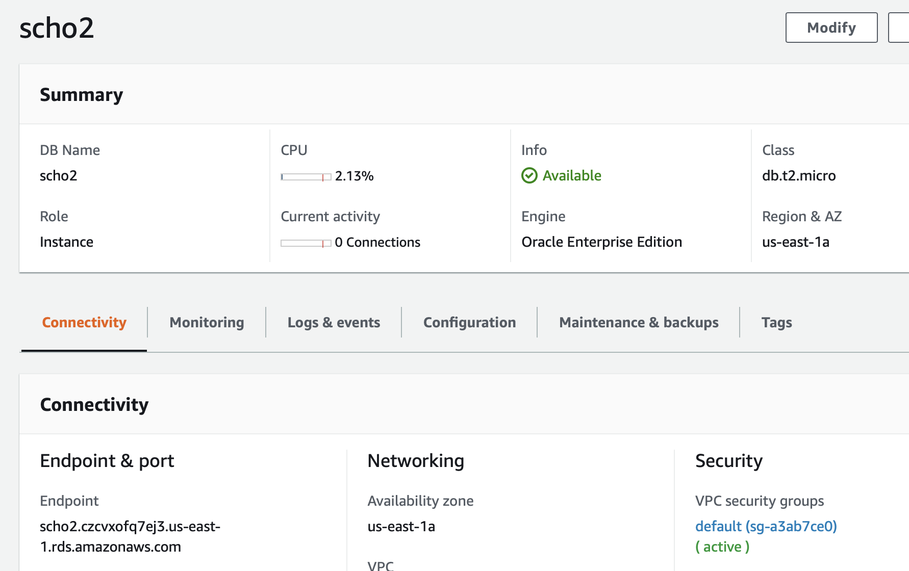

Successfully connect to RDS

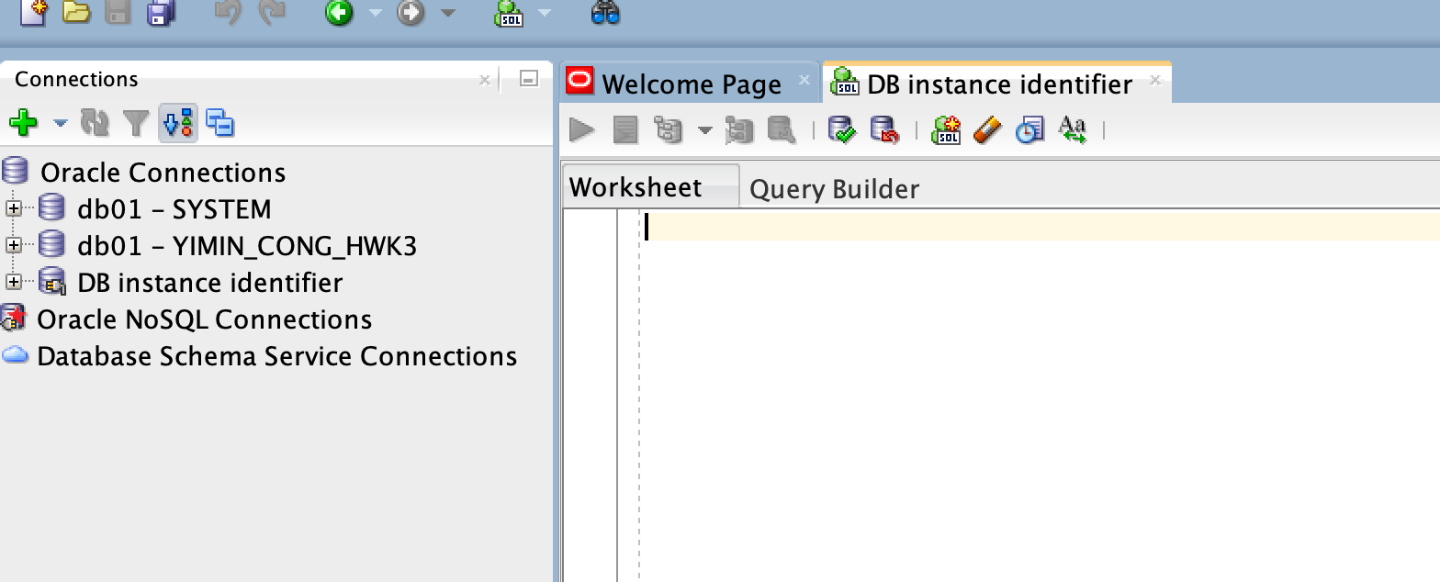

Run the script

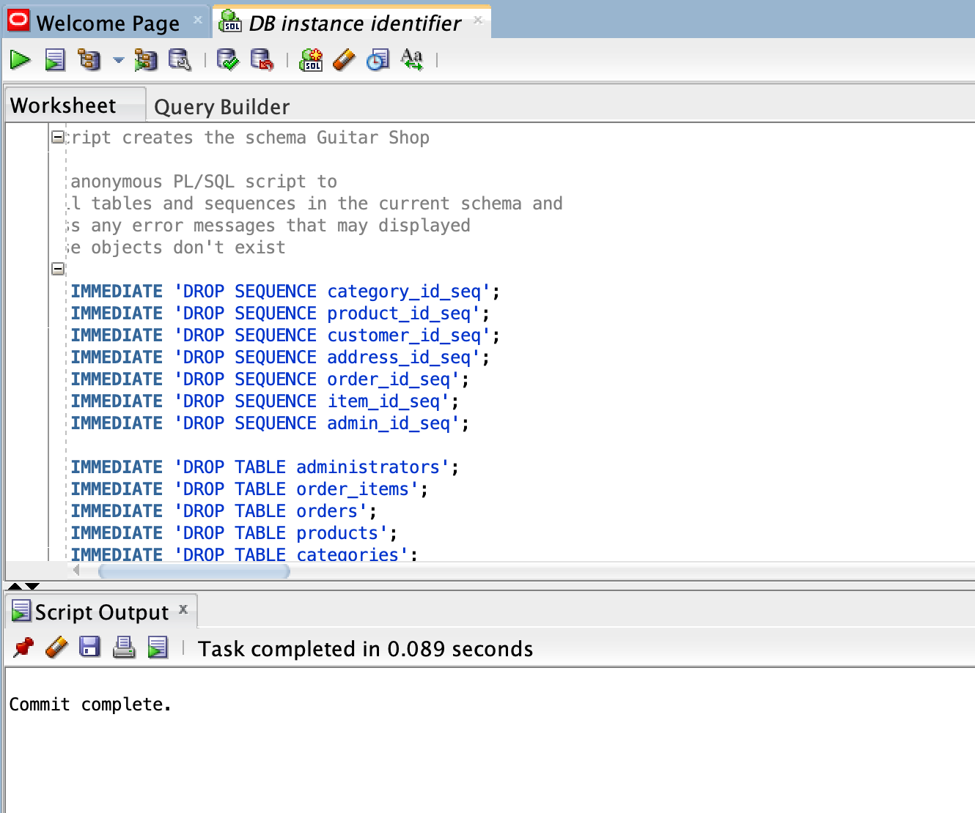

Connect to data modeler 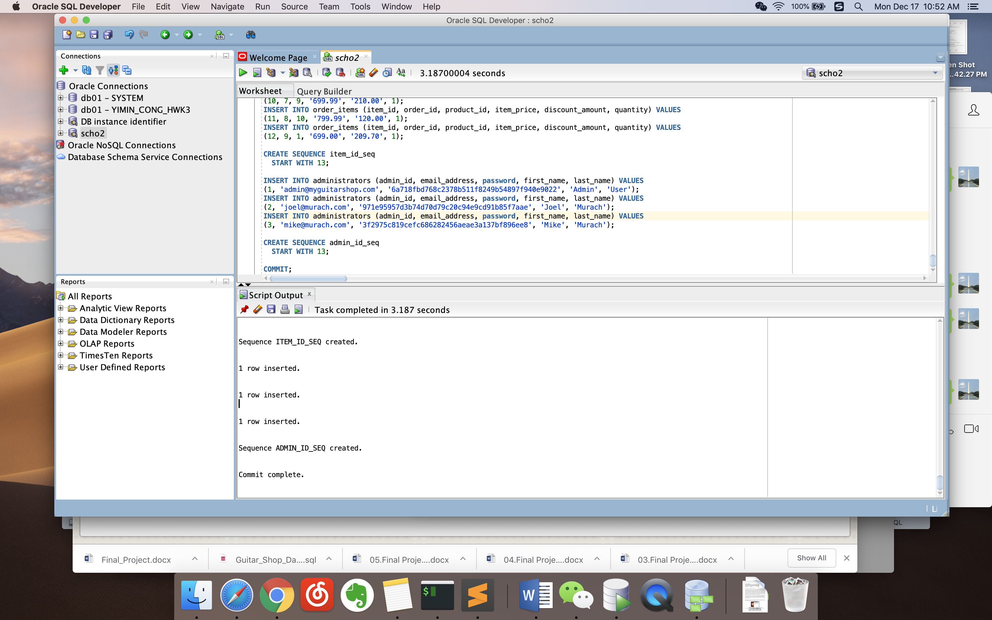

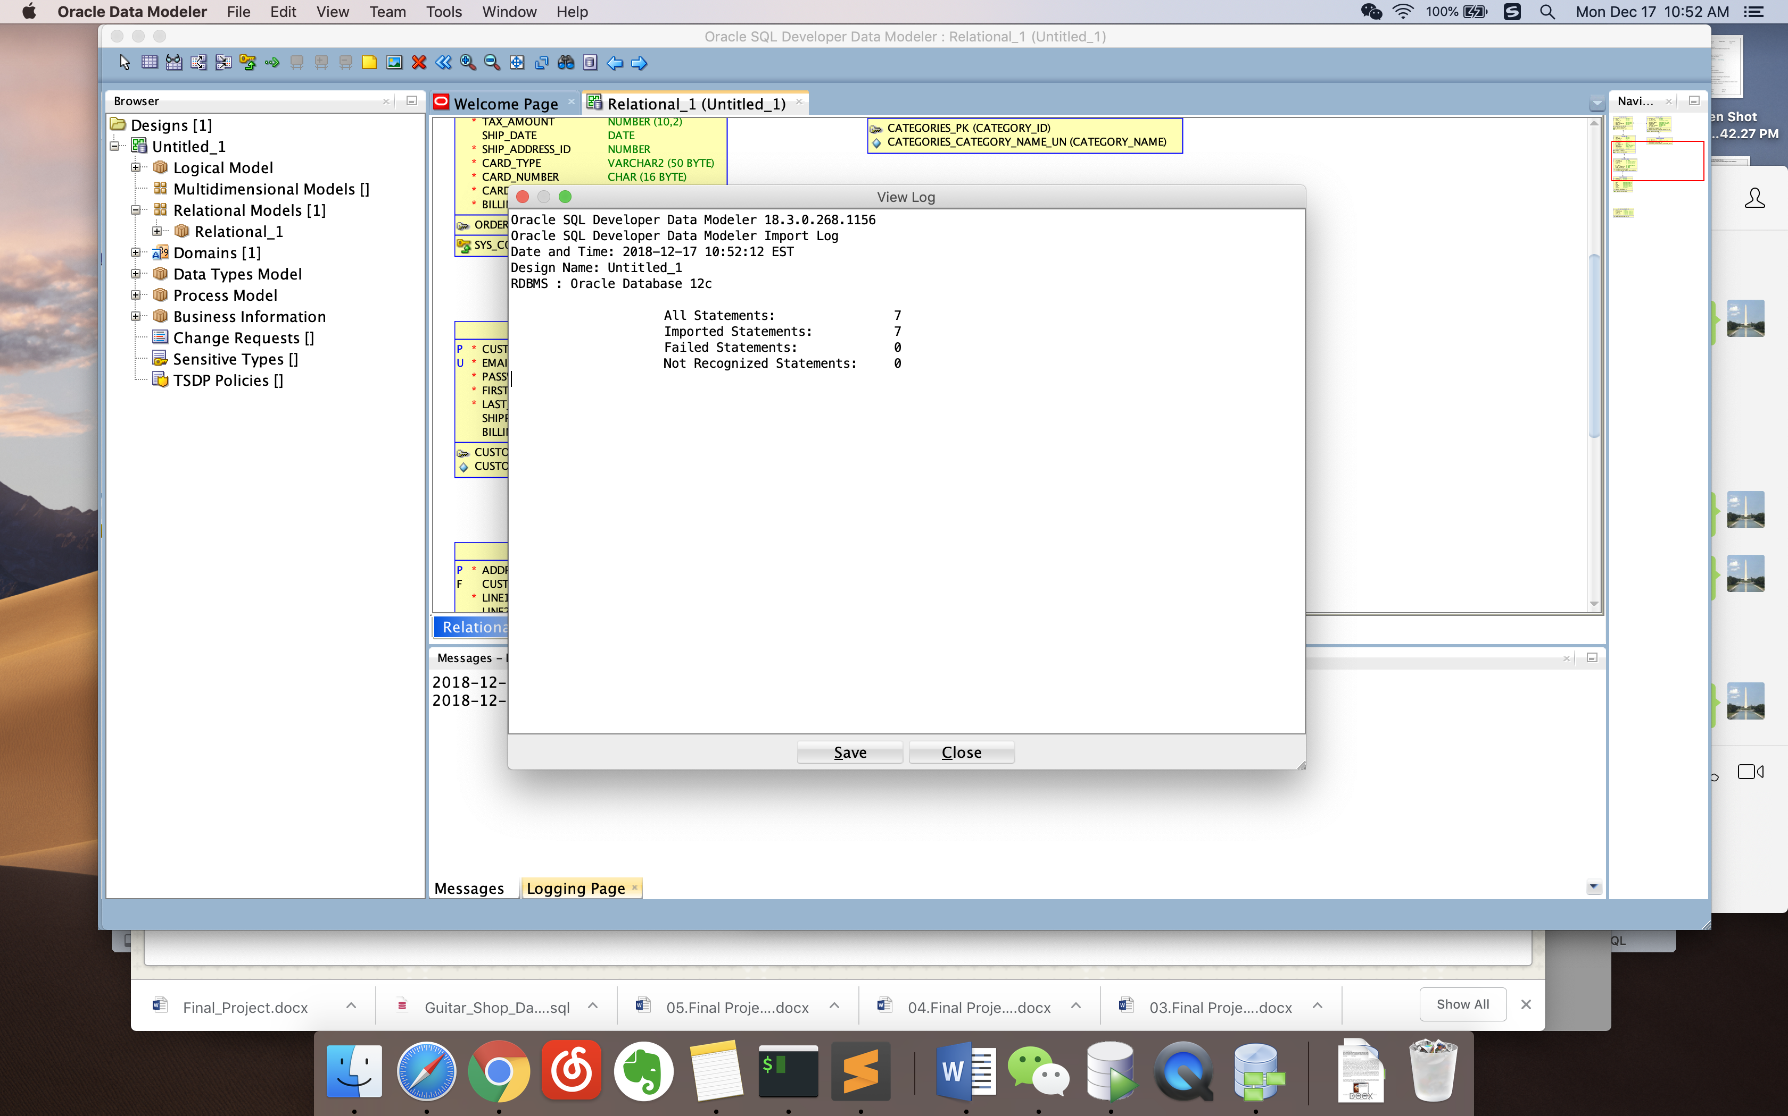

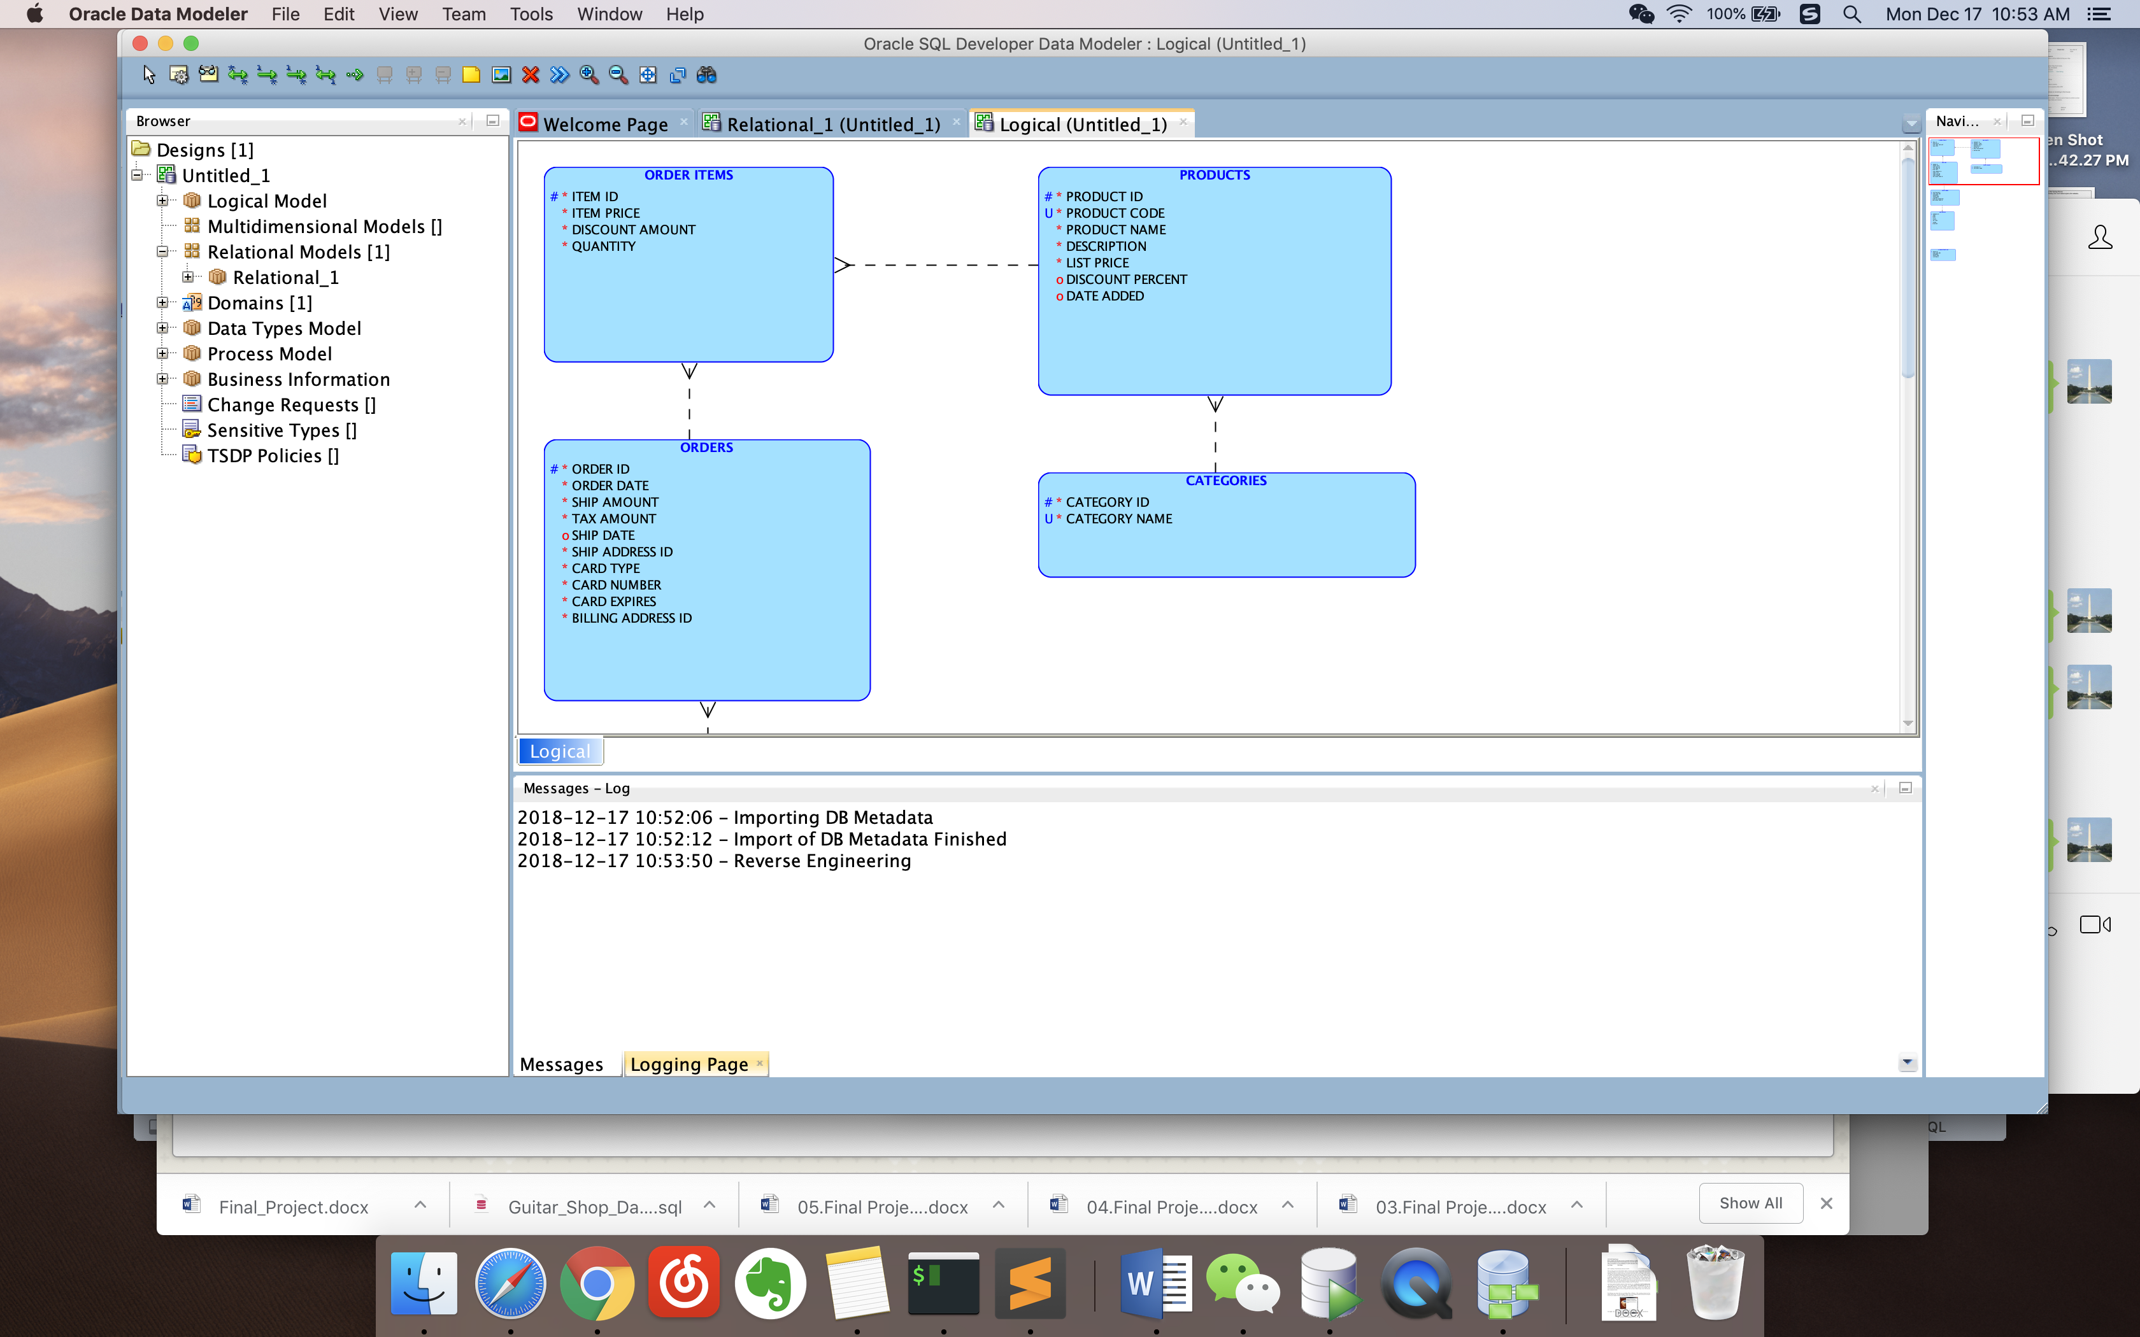

Summary:

From this lab, I learned how to deploy an AWS RDS instance and how to connect data modeler to RDS.